The University of Toledo
College of Engineering
CSET4750 Computer Networks and Data Communications
Final Project - 20 points
- Using the IPv6 network assigned specifically to you (posted on Blackboard) design an IPv6 sub-network (using CIDR notation) that will meet the needs of Acme Corporation (from LAB 8). The selected option must follow good network design goals. Develop an IP network number scheme for each type of device on the network. Apply your network IP number scheme by assigning IP addresses to types of devices used at each location. Diagram the entire network applying this scheme.
The ipv6 address assigned to me for this project was “2001:2b97:ca1d”
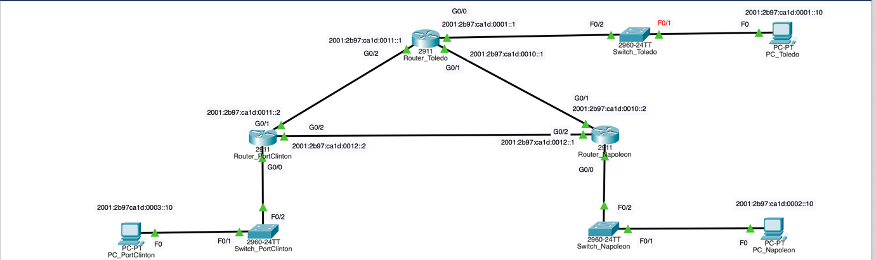
- Using GNS3 or Cisco Packet Tracer complete the set-up of each router, switch, and PC in the Toledo-Napoleon-Port Clinton scenario.
  - Each Router must use IPv6 Addressing
  - Each location must have a switch connected to an Ethernet port
The switch does not need to have an IP address assigned
  - Each switch must have at least one PC connected using IPv6 addressing
Using the above mentioned IPv6 block I have come up with a ipv6 addressing scheme which is as follows
All the routers have the ipv6 address 2001:2b97:ca1d:xx1x::x
All the switches have the ipv6 address 2001:2b97:ca1d:xx1x::x. All the Pc’s have the ipv6 address 2001:2b97:ca1d:xx1x::x.

All the routers have the ipv6 address 2001:2b97:ca1d:001x::x
The connection between Toledo’s router and port Clinton’s router is 2001:2b97:ca1d:0011::x
The connection between Toledo’s router and Napoleon’s router is
2001:2b97:ca1d:0010::x
The connection between Port Clintons router and Napoleon’s router is
2001:2b97:ca1d:0012::x
The above Ip address scheme makes it easy for us to figure out what kind of a device it is and its location.
Configuration of the PC’s:
Toledo PC
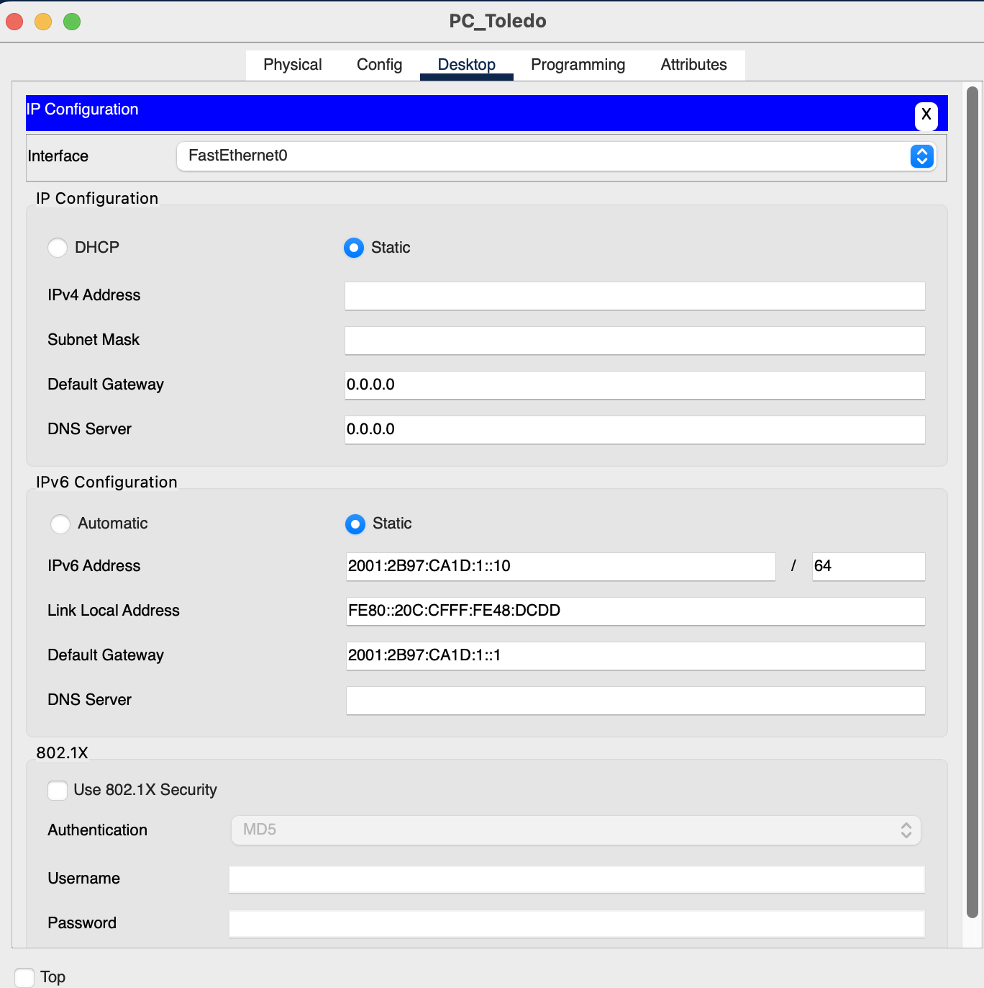
Port Clinton PC:
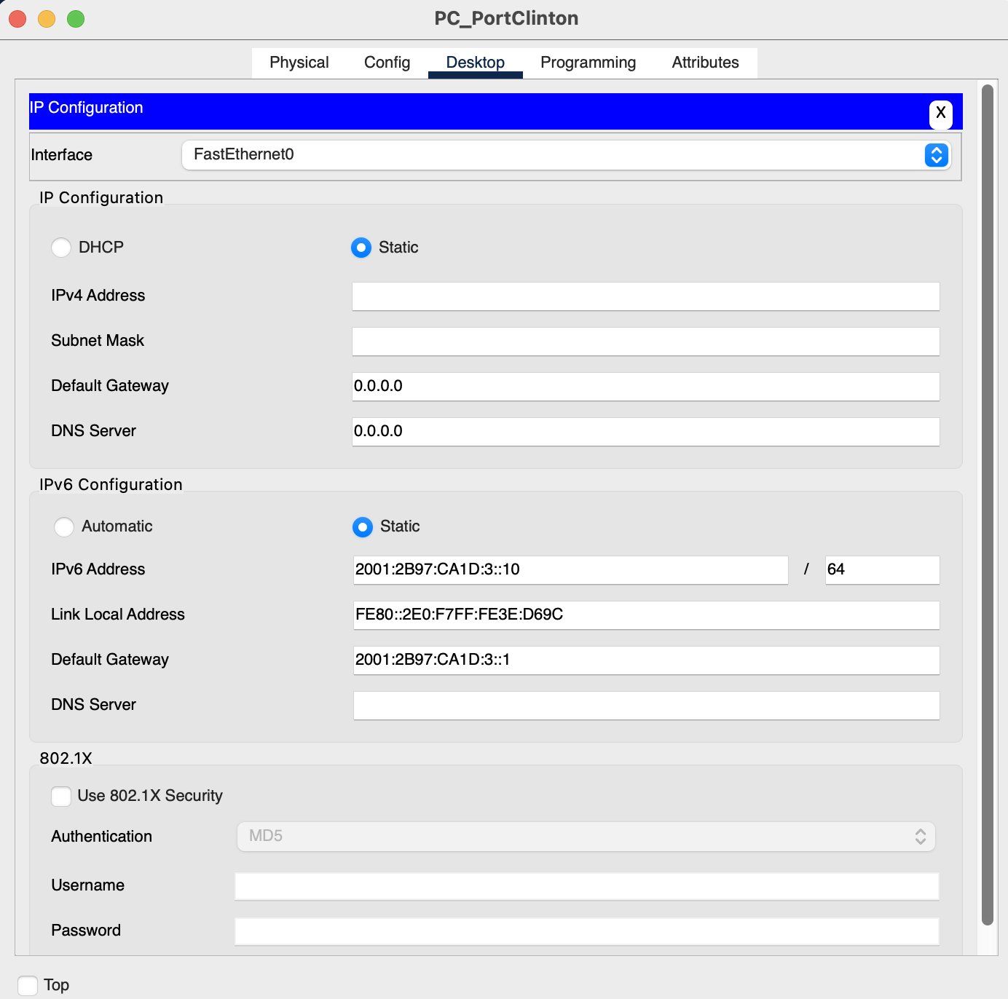

Napoleon PC:
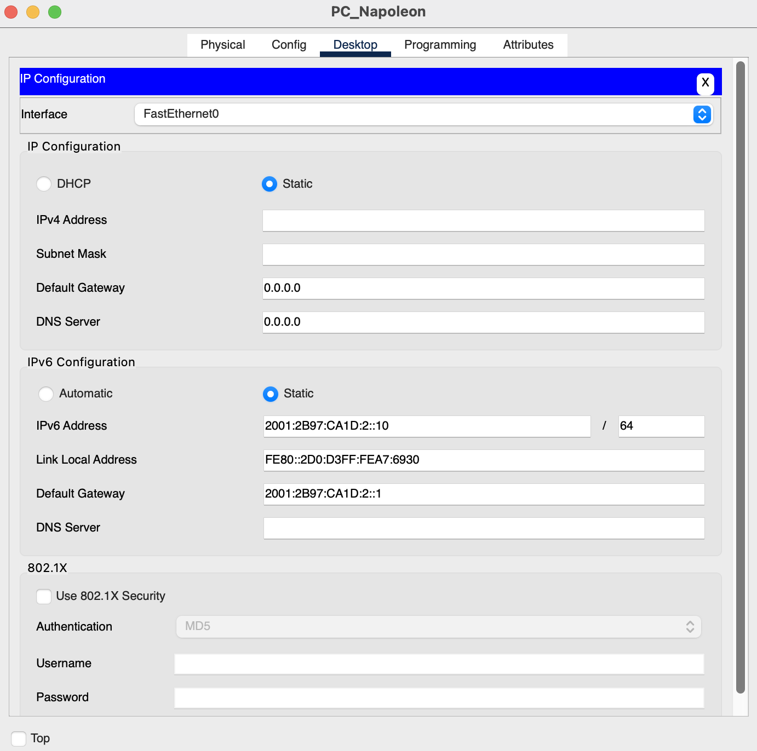

3. Apply the configuration statements to enable static route entries to allow all devices on the inter-network to communicate?
Command format: ipv6 route <destination> <next-hop>
Commands executed on the Toledo router :
ipv6 route 2001:2B97:CA1D:2::/64 2001:2B97:CA1D:10::2
ipv6 route 2001:2B97:CA1D:3::/64 2001:2B97:CA1D:11::2
Result
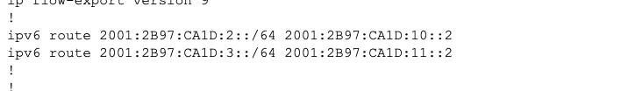
Route table:
Command used: show ipv6 route
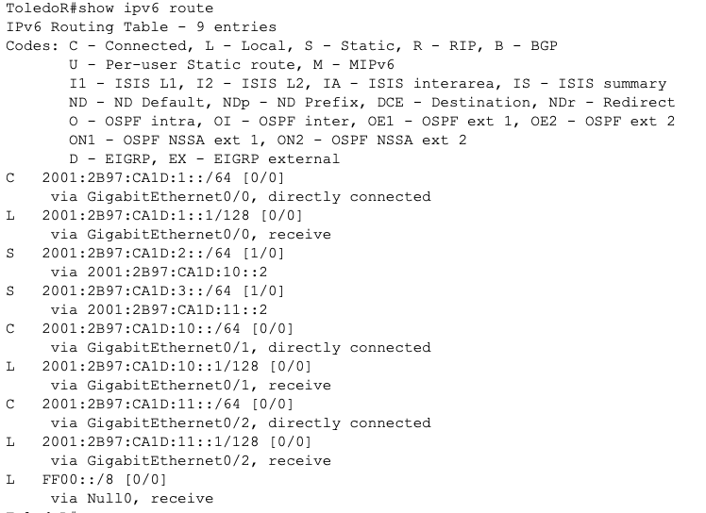
Commands executed on the Port Clinton router:
ipv6 route 2001:2B97:CA1D:1::/64 2001:2B97:CA1D:11::1. ipv6 route 2001:2B97:CA1D:2::/64 2001:2B97:CA1D:12::1
Result:
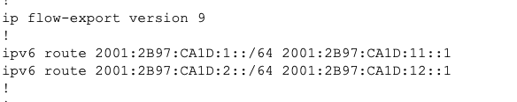
Route table:
Command used: show ipv6 route
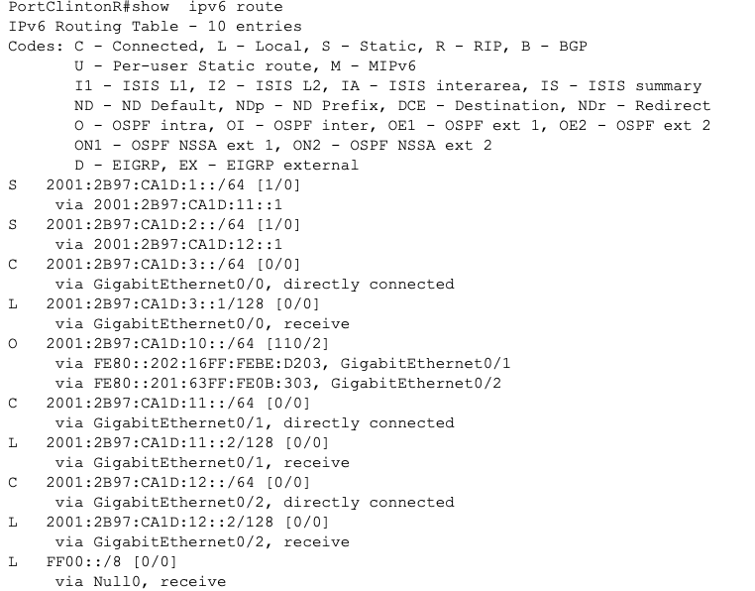

Commands executed on the Napoleon router:
ipv6 route 2001:2B97:CA1D:1::/64 2001:2B97:CA1D:10::1
ipv6 route 2001:2B97:CA1D:3::/64 2001:2B97:CA1D:12::2
Result:
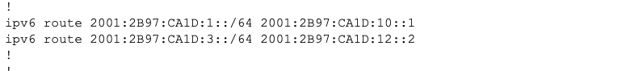
Route table:
Command used: show ipv6 route
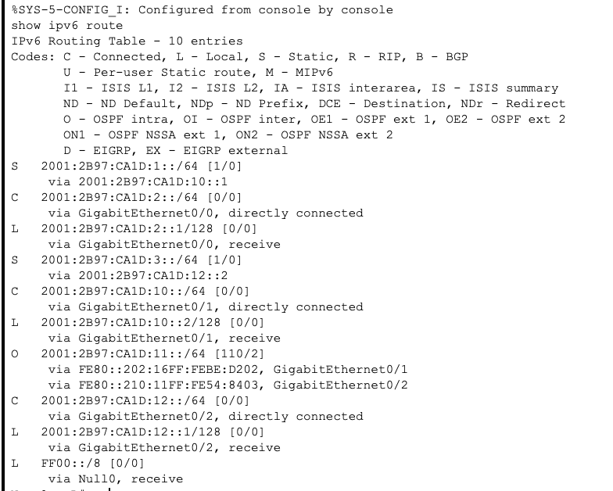

- Apply the configuration statements to enable IPv6 RIP dynamic routing protocol to allow all devices on the inter-network to communicate?
Command format:
First on router: ipv6 router rip ACME-RIP
exit
Then on the individual interfaces:
interface GigabitEthernet x/x
ipv6 rip ACME-RIP enable
exit
Commands executed on the Toledo router:
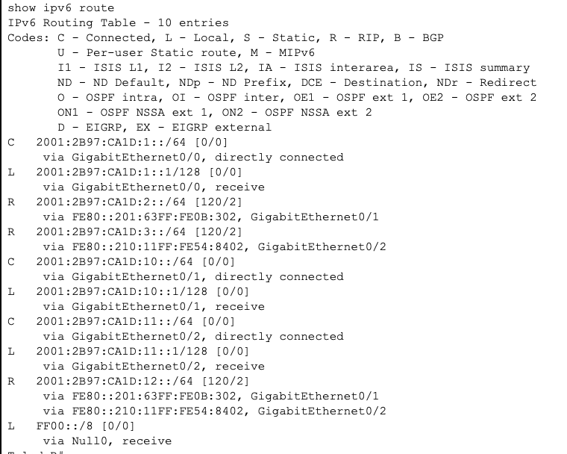
Commands executed on the Port Clinton router:
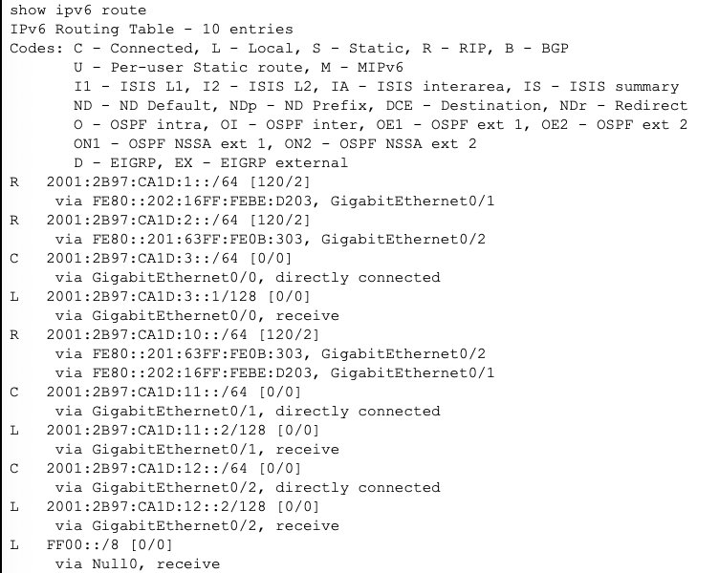

Commands executed on the Napoleon router:
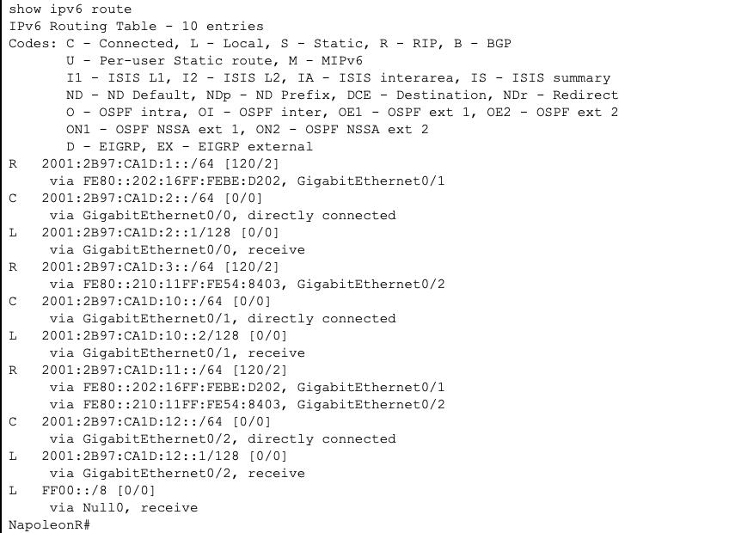

- Apply the configuration statements to enable IPv6 OSPF dynamic routing protocol to allow all devices on the inter-network to communicate?
Command format:
First on router:
ipv6 router ospf 1
router-id 1.1.1.1 for (Port Clinton)
router-id 2.2.2.2 for (Toledo)
router-id 3.3.3.3 for (Napoleon)
exit
Then on all the interfaces:
interface GigabitEthernet x/x
ipv6 ospf 1 area 0
exit
Toledo Router:
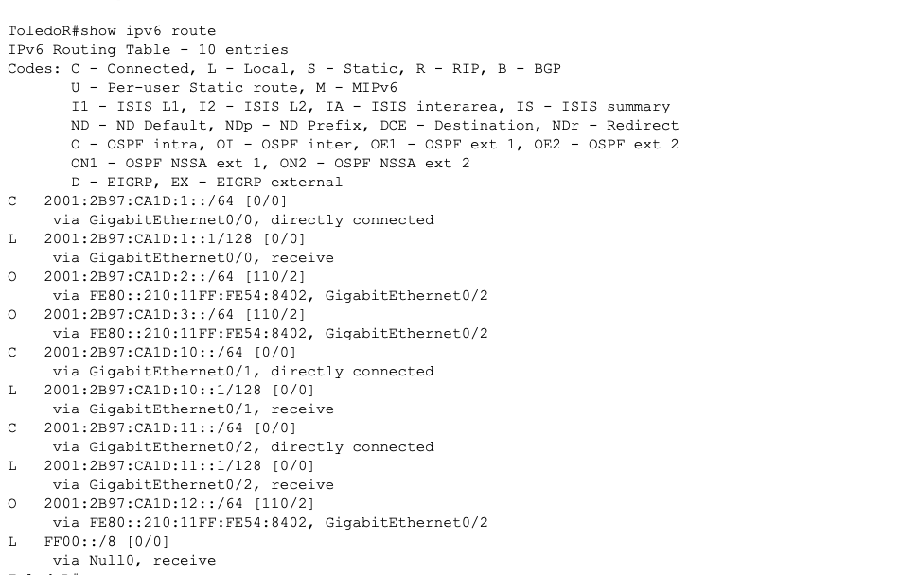
Config file:
Using 919 bytes
!
version 15.1
no service timestamps log datetime msec
no service timestamps debug datetime msec
no service password-encryption
!
hostname ToledoR
!
!
!
!
!
!
!
!
ip cef
ipv6 unicast-routing
!
no ipv6 cef
!
!
!
!
license udi pid CISCO2911/K9 sn FTX1524SH8S-
!
!
!
!
!
!
!
!
!
!
!
spanning-tree mode pvst
!
!
!
!
!
!
interface GigabitEthernet0/0
no ip address
duplex auto
speed auto
ipv6 address 2001:2B97:CA1D:1::1/64
ipv6 ospf 1 area 0
!
interface GigabitEthernet0/1
no ip address
duplex auto
speed auto
ipv6 address 2001:2B97:CA1D:10::1/64
ipv6 ospf 1 area 0
!
interface GigabitEthernet0/2
no ip address
duplex auto
speed auto
ipv6 address 2001:2B97:CA1D:11::1/64
ipv6 ospf 1 area 0
!
interface Vlan1
no ip address
shutdown
!
ipv6 router ospf 1
router-id 2.2.2.2
log-adjacency-changes
!
ip classless
!
ip flow-export version 9
!
!
!
!
!
!
!
line con 0
!
line aux 0
!
line vty 0 4
login
!
!
!
End

Port Clinton router:
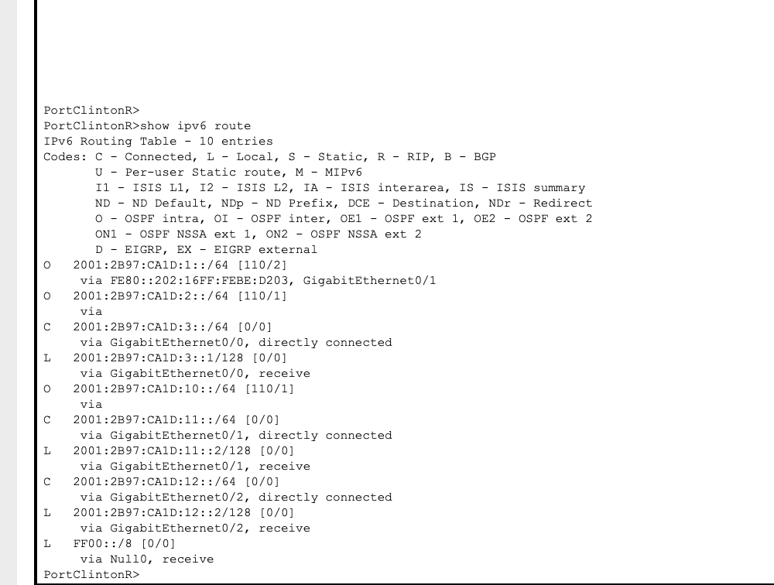
Config file
Building configuration...

Current configuration : 1040 bytes
!
version 15.1
no service timestamps log datetime msec
no service timestamps debug datetime msec
no service password-encryption
!
hostname PortClintonR
!
!
!
!
!
!
!
!
ip cef
ipv6 unicast-routing
!
no ipv6 cef
!
!
!
!
license udi pid CISCO2911/K9 sn FTX1524RZDN-
!
!
!
!
!
!
!
!
!
!
!
spanning-tree mode pvst
!
!
!
!
!
!
interface GigabitEthernet0/0
no ip address
duplex auto
speed auto
ipv6 address 2001:2B97:CA1D:3::1/64
ipv6 ospf 1 area 0
!
interface GigabitEthernet0/1
no ip address
ipv6 traffic-filter BLOCK-ICMP in
duplex auto
speed auto
ipv6 address 2001:2B97:CA1D:11::2/64
ipv6 ospf 1 area 0
!
interface GigabitEthernet0/2
no ip address
duplex auto
speed auto
ipv6 address 2001:2B97:CA1D:12::2/64
ipv6 ospf 1 area 0
!
interface Vlan1
no ip address
shutdown
!
ipv6 router ospf 1
router-id 1.1.1.1
log-adjacency-changes
!
ip classless
!
ip flow-export version 9
!
!
ipv6 access-list BLOCK-ICMP
deny icmp any any echo-request
permit ipv6 any any
!
!
!
!
!
line con 0
!
line aux 0
!
line vty 0 4
login
!
!
!
end

Napoleon router:
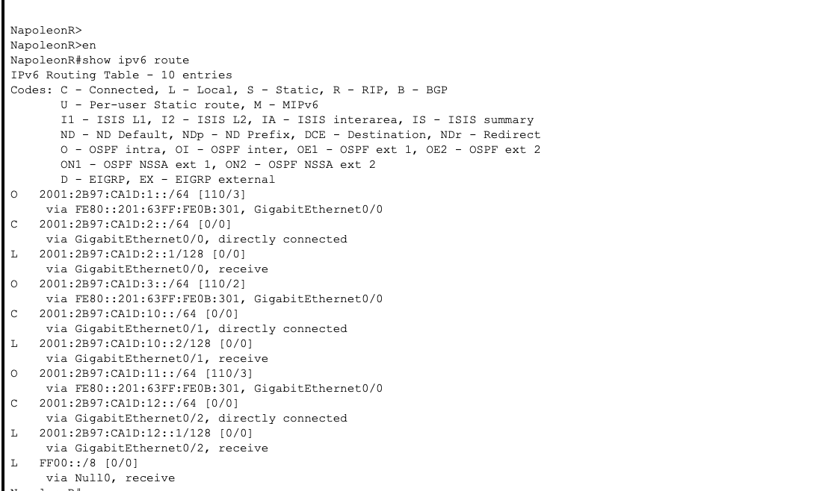
Config file
version 15.1
no service timestamps log datetime msec
no service timestamps debug datetime msec
no service password-encryption
!
hostname NapoleonR
!
!
!
!
!
!
!
!
ip cef
ipv6 unicast-routing
!
no ipv6 cef
!
!
!
!
license udi pid CISCO2911/K9 sn FTX1524LK78-
!
!
!
!
!
!
!
!
!
!
!
spanning-tree mode pvst
!
!
!
!
!
!
interface GigabitEthernet0/0
no ip address
duplex auto
speed auto
ipv6 address 2001:2B97:CA1D:2::1/64
ipv6 rip ACME_RIP enable
ipv6 ospf 1 area 0
!
interface GigabitEthernet0/1
no ip address
duplex auto
speed auto
ipv6 address 2001:2B97:CA1D:10::2/64
ipv6 rip ACME_RIP enable
ipv6 ospf 1 area 0
!
interface GigabitEthernet0/2
no ip address
duplex auto
speed auto
ipv6 address 2001:2B97:CA1D:12::1/64
ipv6 rip ACME_RIP enable
ipv6 ospf 1 area 0
!
interface Vlan1
no ip address
shutdown
!
ipv6 router ospf 1
router-id 3.3.3.3
log-adjacency-changes
!
ipv6 router rip ACME_RIP
!
ip classless
!
ip flow-export version 9
!
!
!
!
!
!
!
line con 0
!
line aux 0
!
line vty 0 4
login
!
!
!
end

Create an IPv6 Extended ACL to block ping echo request from your network.
steps to block the ping requests:
PortClintonR(config)#ipv6 access-list BLOCK-ICMP
PortClintonR(config-ipv6-acl)#deny icmp any any echo-request
PortClintonR(config-ipv6-acl)#permit ipv6 any any
PortClintonR(config-ipv6-acl)#exit
PortClintonR(config)#int g0/1
PortClintonR(config-if)#ipv6 traffic-filter BLOCK-ICMP in
PortClintonR(config-if)#exit
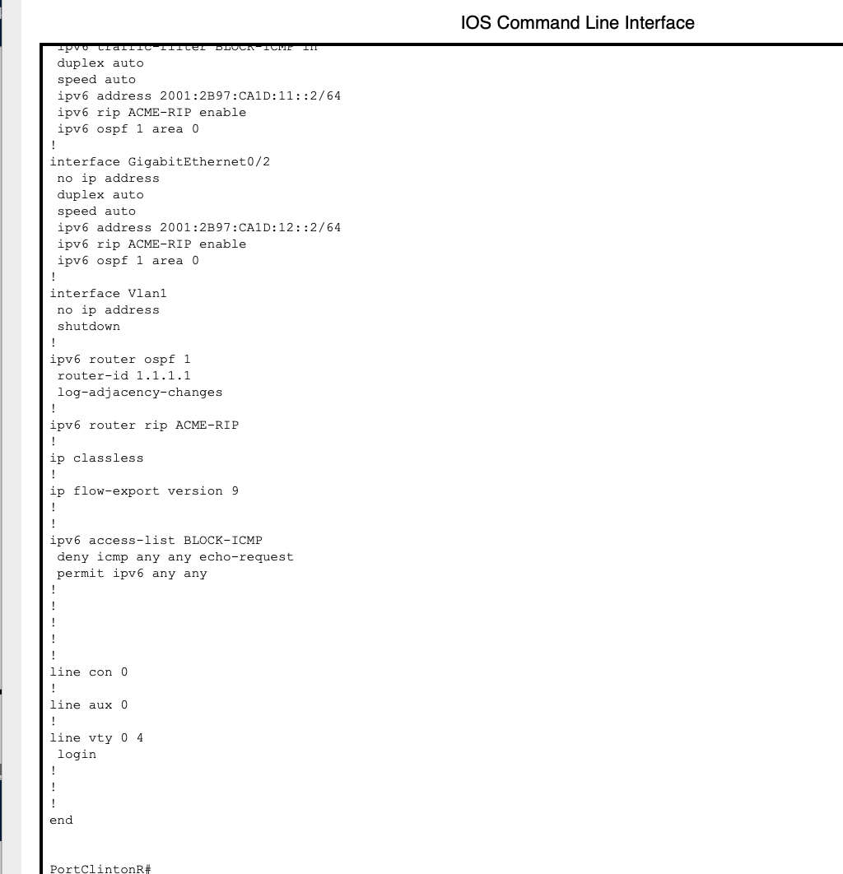
Before blocking ICMP on the port Clinton router.
Ping from the PC
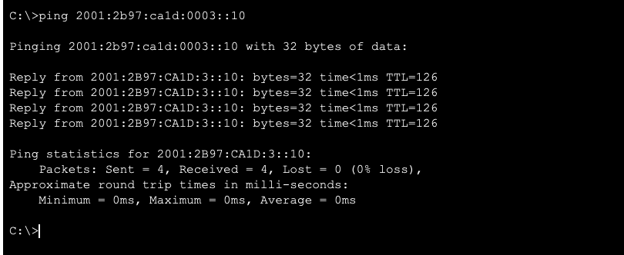
Ping from the router:
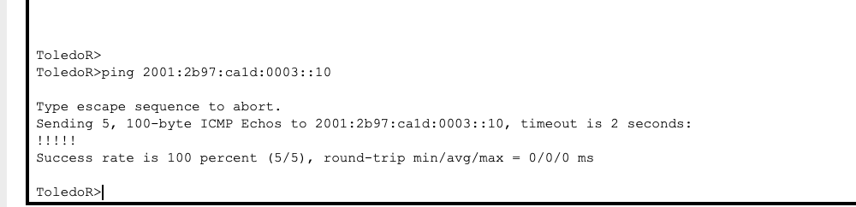
After blocking the ICMP on the port Clinton router

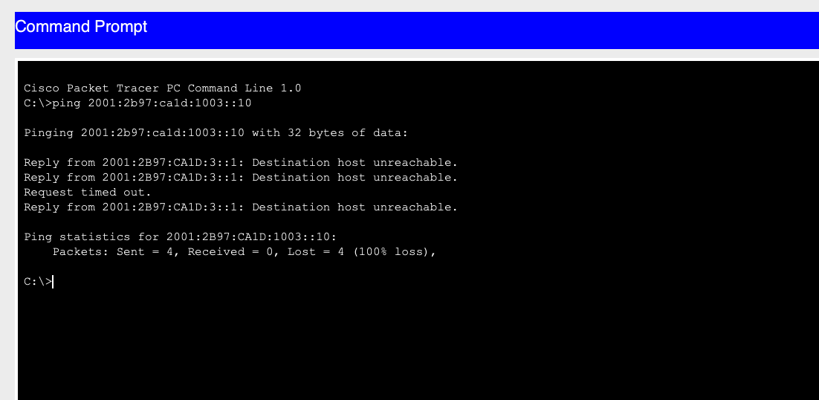
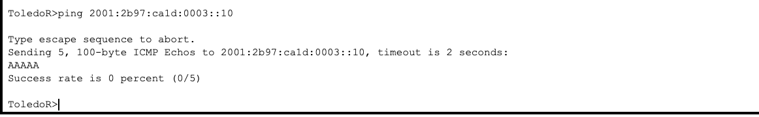

Copies of all the config files, Route Tables, Screen Shots of the successful pings and for question 6 – the blocked pings, and the network diagram including your IP addressing scheme will be turned in on the last day of class.
NOTE: You must have config files and route tables for each of the 3 routers for each task.

